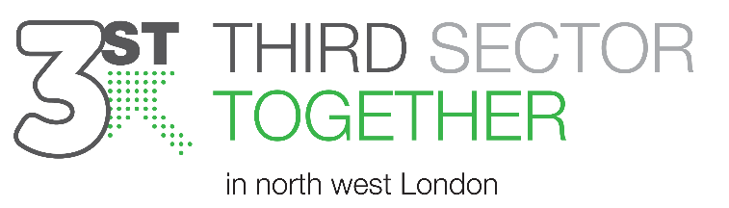
Terms & Conditions
Membership Portal Usage
Last updated: 24.11.2023

Please read these Terms and Conditions ("Terms", "Terms and Conditions") carefully before applying for membership through the website: https://www.3stnwl.org.uk/membership-portal operated by Third Sector Together North West London, also referenced as 3ST, ("us", "we", or "our").

By submitting your membership form, accessing and/or using the membership portal service in any capacity you are agreeing to comply with and be bound by the terms and conditions of this service. If you disagree with any part of the terms, then we may not permit you to access the membership portal (“service”).

These Terms apply to all visitors, users and others who access or use this specific service.

What is the membership portal site?
Once someone registers themselves, on behalf of their organisation, they will represent that organisation through their engagement and use of the service. This portal site allows members to share ideas and resources that are solely related to their organisations’ delivery, collaborations and/or potential partnerships with any other member and/or 3ST. We ask that members use this portal as a resource for collaboration and NOT to: advertise, promote or sell services of individuals or for any financial benefits or gains.

1. Process
Once a member has registered their application will be reviewed. 3ST reserve the right to reject membership forms and rights of access to the membership portal if the organisations does not fit within the criteria or at our sole discretion. Those applying for membership will receive a notification via email once a decision has been made.

2. Content
Our service allows you to share, save and interact with other members through folders, and otherwise make available certain information, text, graphics, videos, or other material ("content").
Error! No bookmark name given.The membership portal / service should not be used for non-business purposes (including social networking). This applies whether during working hours or non-working hours. Use of our service for the purpose for which they are not intended may result in removal of your access and account from the service.

Below are typical of infringements that 3ST regard as usage of our service outside of the purpose for which they are intended and can result in removal of accounts, restricted access and sometimes reporting to authorities depending on the seriousness of the content shared within the service.

The examples below are indicative and not exhaustive:
- Advertising, promoting or selling services of individuals or for any financial benefits or gains.
- Sending messages or images that are potentially offensive, libellous, obscene or contravene our equal opportunities policy or organisational ethos
- Sending messages or images that could constitute bullying or harassment or are potentially detrimental to the organisation’s interests
- Accessing, uploading or distributing pornography: images, graphics or text depicting nudity, intercourse or sexual acts, obscene or indecent material from any source is forbidden and will be grounds for immediate removal and restriction from using the service as well as reporting to a higher authority within your organisation for misuse of partnership services. The storing and transfer of such images using any 3ST service or system is forbidden
- Excessive or inappropriate use of the service, including divulging personal details / sensitive information about you, a client or anyone else, engaging in or circulating rumours / gossip, using expletive language / aspersions
- Uploading images, pages or contributions on external websites (including social networking sites) without express approval/consent. This restriction relates to our organisation, any employee, client, supplier, stakeholder etc.,
- Sharing links to external sites can be done if appropriate to the work being discussed or in relation to the delivery of your organisations services. Any link shared
- must be from a secure site and source before sharing
- Uploading or distributing copyright information without disclosing source of ownership.
Much of what appears online is, or claims to be, protected by copyright. If so, only the owner of the copyright is allowed to copy the information. Any copying without permission, including electronic copying, is prohibited. The copyright laws apply not only to documents but also to software. If in doubt over the copyright of an internet document, ask for advice from your line manager, marketing lead or your Chief Executive.
3. Privacy
3ST has implemented appropriate technical and organisational measures to ensure that data is processed in line with the principles set out in the GDPR. 3ST provide a comprehensive, clear and transparent Privacy Notice.
Terms of membership do not allow for personal, confidential / private information to be shared between members through using the service and we will not require the collection of any personal, confidential / private information for the use of our service. The only data expected of you will be:
- Name (first and last), work email and work telephone number.
The retention of your name and contact details are for monitoring use only by our system administrators operating under us and held by the third-party site Wix, who host our website. Other members will be able to see your name only and only be able to contact you through the ‘chat’ function within the membership portal.

Details relating to the organisation you work for are collected for monitoring and data analysis. Your activity within the portal will be monitored and data collected so that we may improve our services and understand how organisations are engaging with the site.

Our Service may contain links to third-party web sites or services that are not owned or controlled by 3ST, such as our host site Wix.

3ST has no control over, and assumes no responsibility for, the content, privacy policies, or practices of any third party web sites or services. You further acknowledge and agree that 3ST shall not be responsible or liable, directly or indirectly, for any damage or loss caused or alleged to be caused by or in connection with use of or reliance on any such content, goods or services available on or through any such web sites or services.

4. Changes

We reserve the right, at our sole discretion, to modify or replace these Terms at any time. Any material revision will be provided with at least 30 days’ notice before any new terms take effect. What is considered a material change will be determined at our sole discretion.

Contact Us
If you have any questions about these Terms, please contact us.

